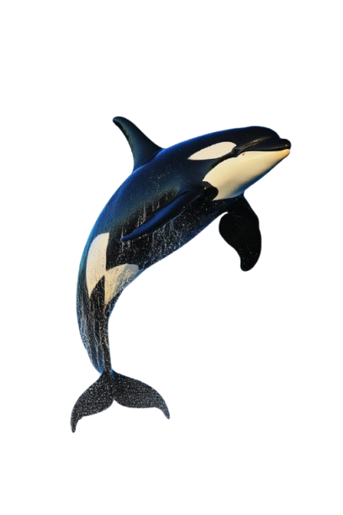
WHALE IMAGE
Monica Nyanduko
WHALE

